**Bug 1 : From Admin/Dentist/Operator Panel :**

**make sure when you edit login or password in dentist/admin/operator panel or when you edit dentist/operator that you do proper validation , right now you can update with empty password or empty login and still works.**

**Display proper validation error message as well for better ux**

**Bug 2: From Admin Panel :**

**when you create an operator account and then try to assign a file with the newly created operator account : it is empty. You need to refresh the page to see the operator name.**

**Bug 3 : From Admin Panel :**

**when you delete an operator account and then try to assign a file to an operator account : You can still see the operator account name. You need to refresh the page in order not to see the deleted operator account**

**Bug 4 : From Admin Panel :**

**Make sure to reset modal operator information and dentist information after you close it or create a new account.**

**Bug 5 : From Admin Panel :**

**Add a cursor pointer css property to those buttons**

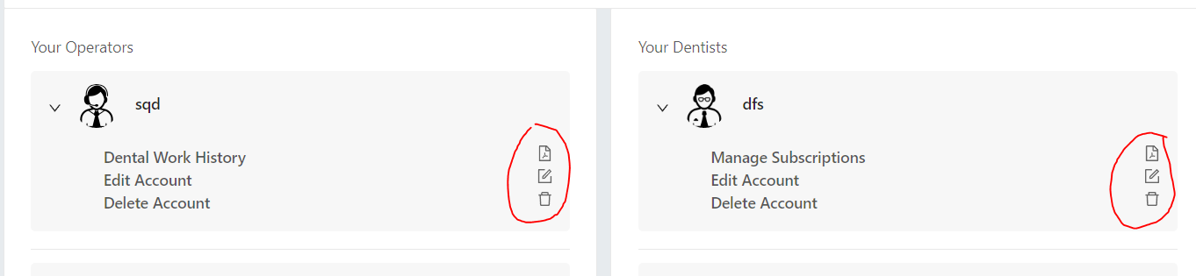

**Bug 6 : From Admin Panel :**

**Missing Adeli number input to update**

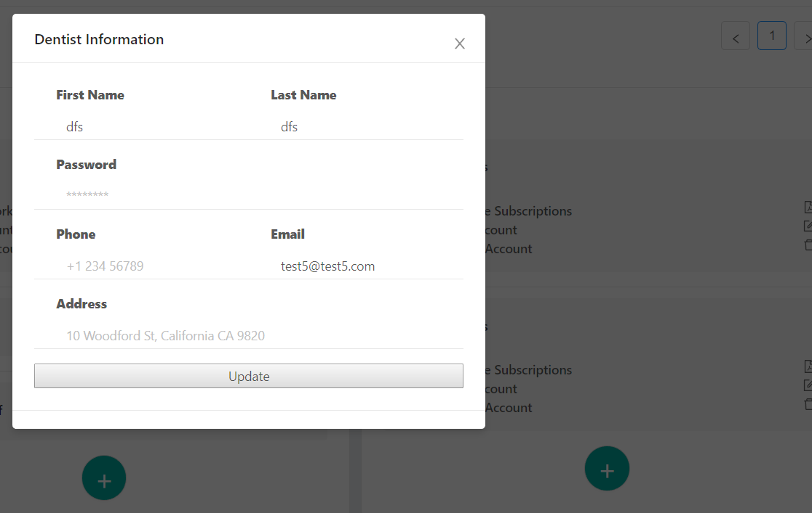

**Bug 7 : From Admin Panel :**

**Add sorting functionalities :**

**For dentist: by dentist name**

**For Status: by status**

**For Date: by date (toggle first click is most recent dates, second click is far away dates)**

**For operator: by operator name (if no operator assigned yet, display empty case first then operator names)**

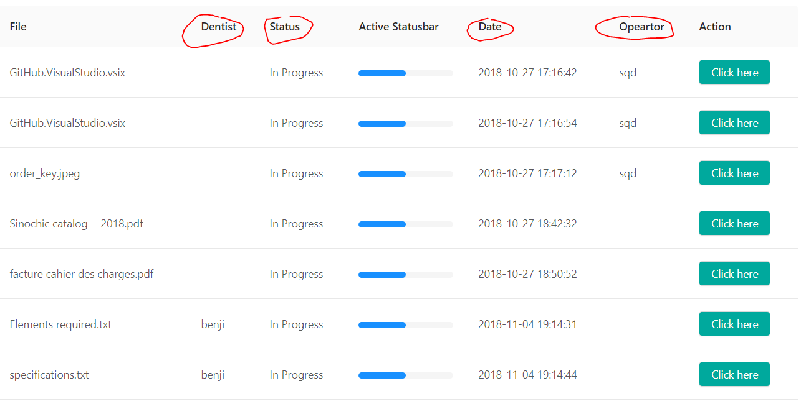

**Bug 8 : From Admin Panel :**

**Put the back button at the top left instead of the bottom**

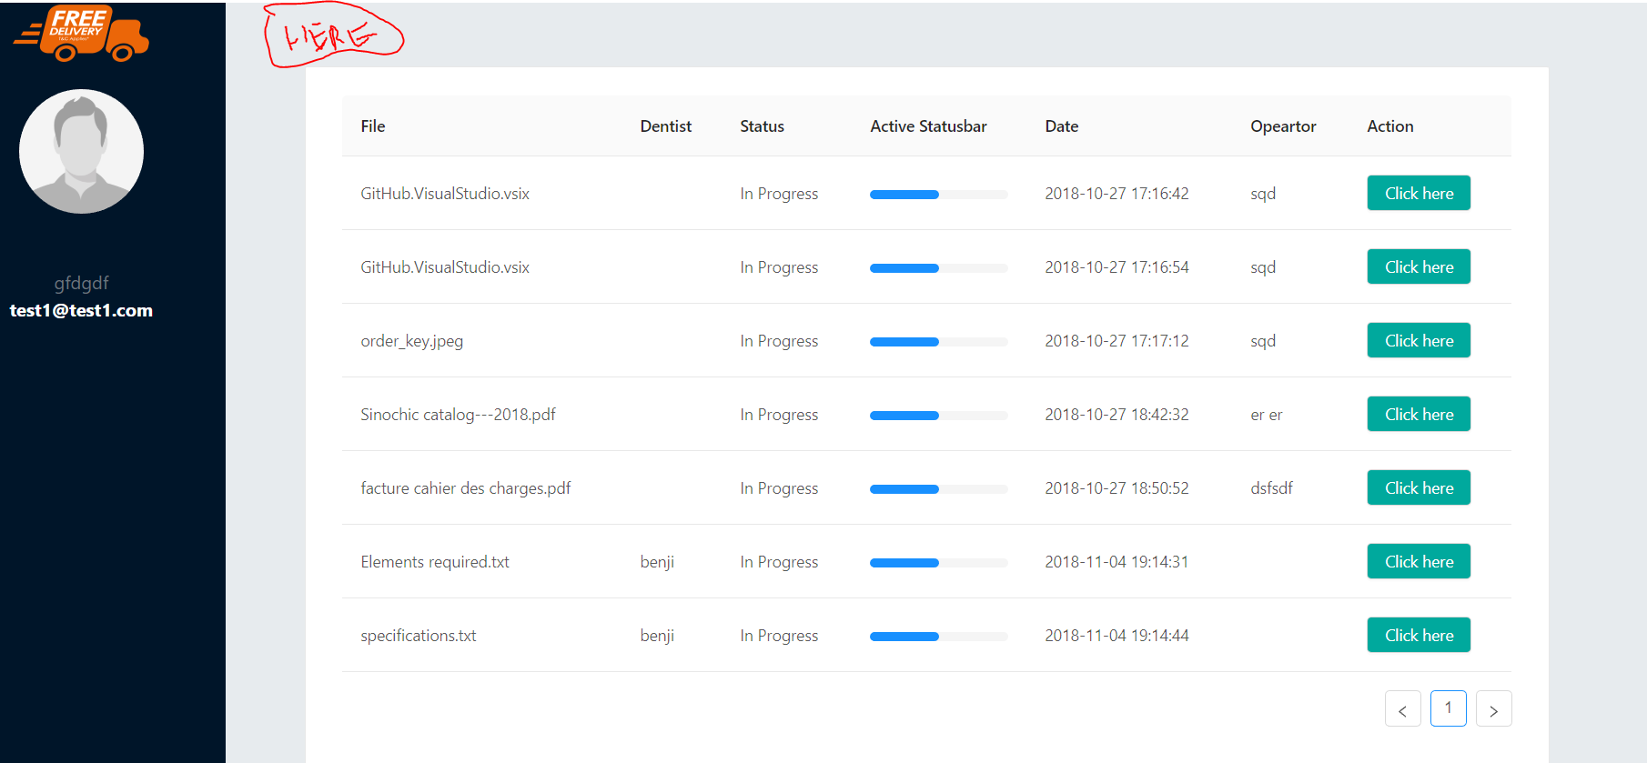

**Bug 9: From Dentist Panel:**

**You should be able to upload file only with the following extension: pdf, img, png, doc, docx**

**Right now you can updated with any extensions file**

**Also add a limit of 10mo per file maximum (I don’t want to overload my database in the future)**

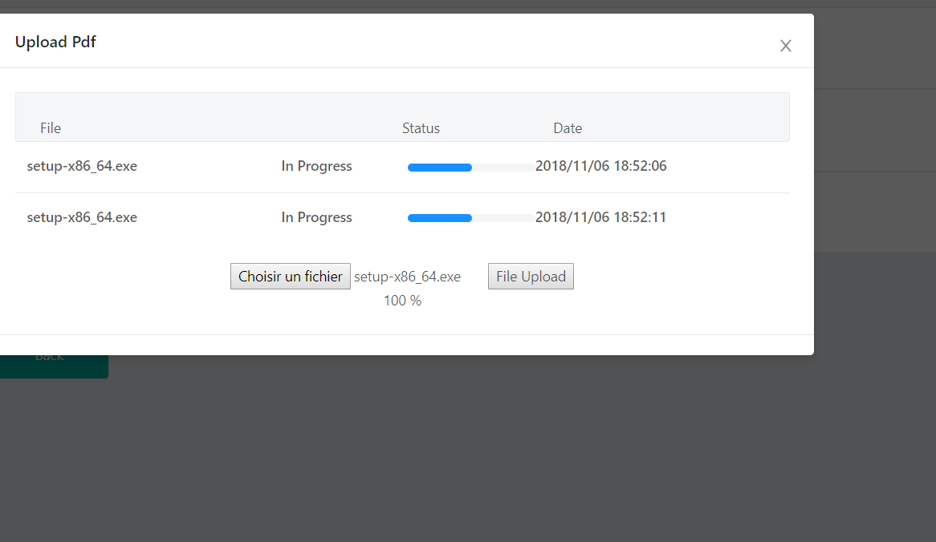

**Bug 10 : From Operator Panel :**

**Add sorting functionalities :**

**For dentist: by dentist name**

**For Status: by status**

**For Date: by date (toggle first click is most recent dates, second click is far away dates)**

**Bug 11 : From Operator Panel :**

**make sure to reset modal when you close or save it**

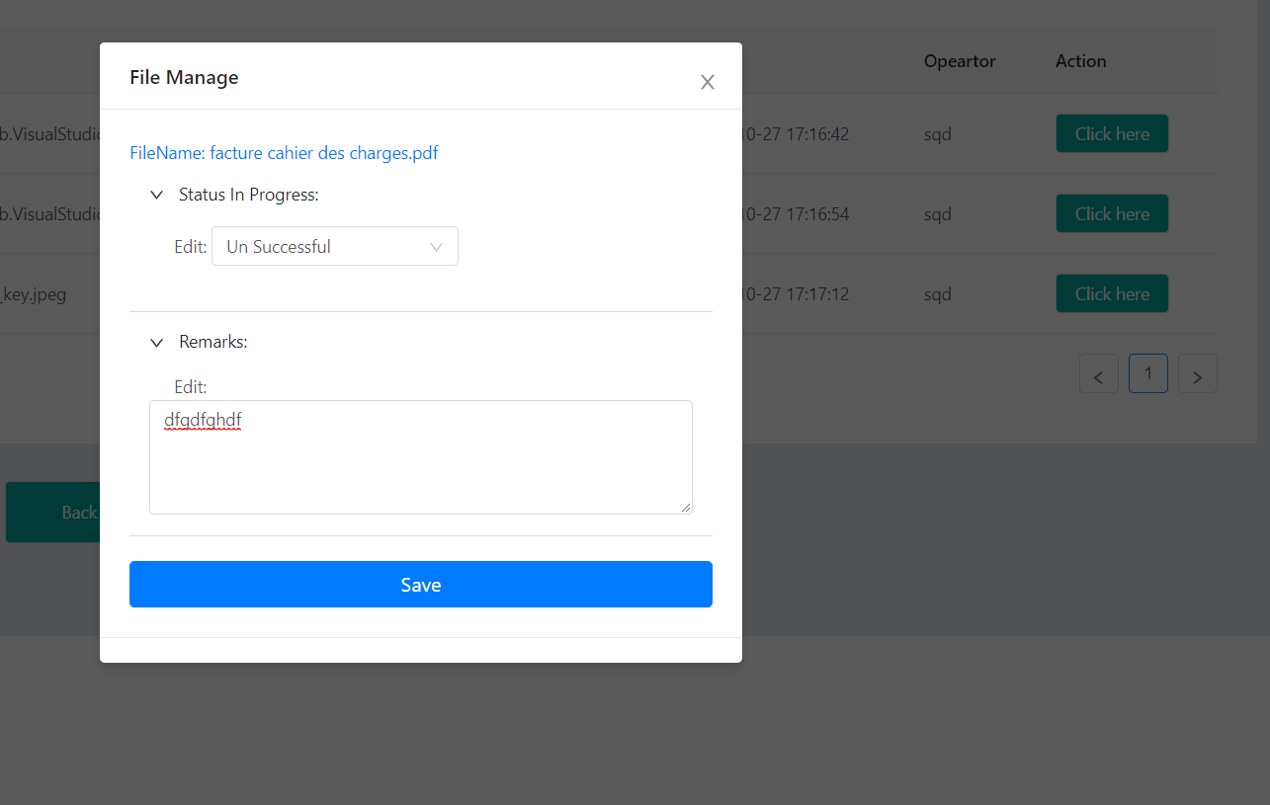

**Bug 12 : From Operator Panel :**

**When you save a document make sure by default the dropdown is always set to “In Progress”.**

**Right now it is empty, making the status empty when you save**

**However you should be able to save without remark, that is ok.**

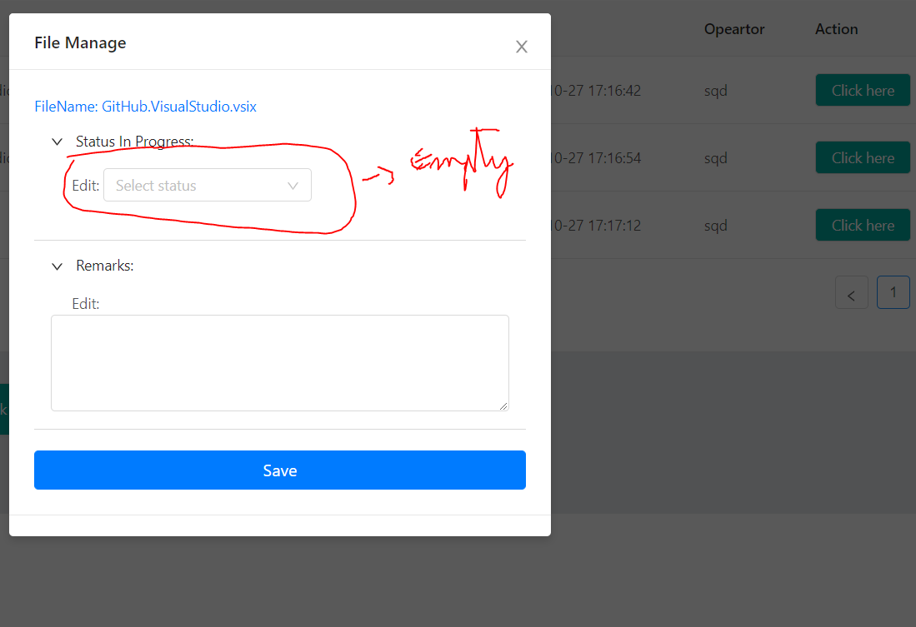

**Bug 13 : From Admin Panel :**

**When I click on download csv file it does not display anything, file is empty**

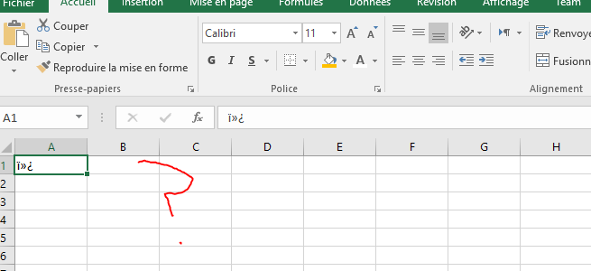

**It should display all the fields I told you last time**

**Bug 14 : From Admin Panel :**

**Add A File , Status and Dentist Category Field to this modal so we know to which dentist and what file the remark was made and what is the status**

**Add also sorting functionalities:**

**For dentist: by dentist name**

**For Status: by status**

**For Date: by date (toggle first click is most recent dates, second click is far away dates)**

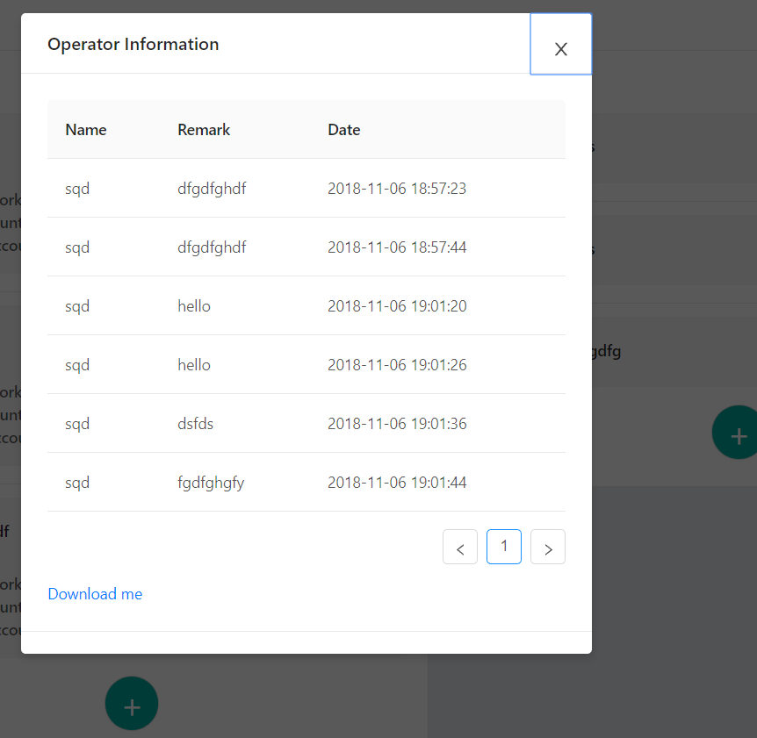

**Missing Features: From Admin Panel and Operator panel: The two blue box button to download dummy excel file**

**Home Page**

**-fix hashtag issue =>** [**http://localhost:3000/#contact**](http://localhost:3000/#contact) **should be /contact not /#contact**